**Docker & Container Internals**

**Build a Docker file for a simple Python flask app**

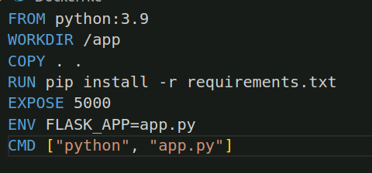

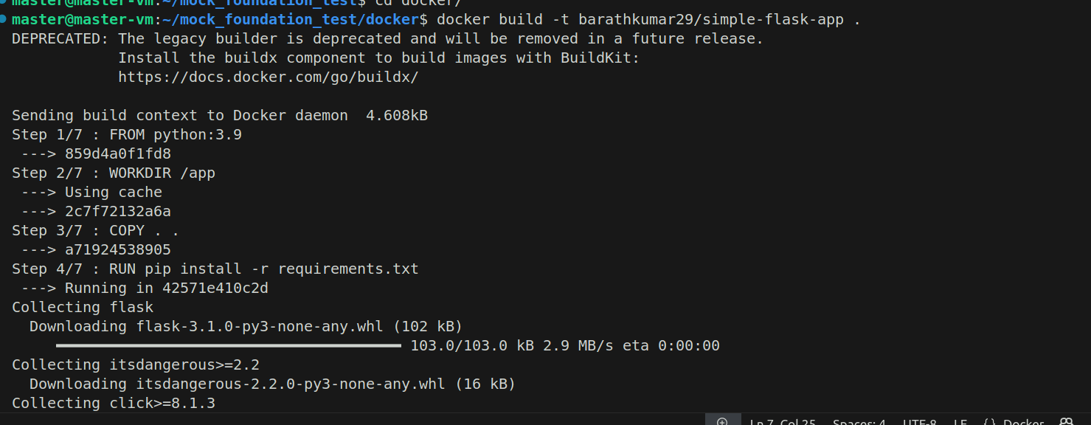

**The container ID**



**The working directory inside the container**



**The read-write layer directory on the host:**

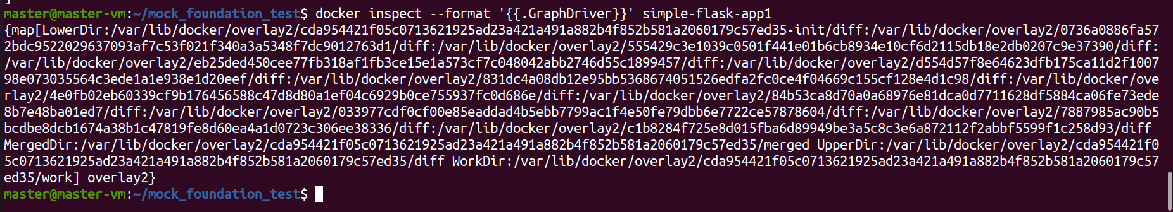

**Command Used:**

**To build the image:**

docker build -t barathkumar29/simple-flask-app .

**To run the image:**

docker run –name -d simple-flask-app -p 5000:5000 barathkumar29/simple-flask-app

**To see the working directory inside the container**

docker exec simple-flask-app1 pwd

**To see the container ID**

docker inspect –format ‘{{.Id}}’ simple-flask-app1

**To see the read-write layer directory on the host:**

docker inspect –format ‘{{.GraphDriver}}’ simple-flask-app1